**安庆市2023年5月模拟结果验证**

**一、气象场**

|  |  |  |  |  |  |  |
| --- | --- | --- | --- | --- | --- | --- |
| **要素** | $$\overline{O}$$ | $$\overline{S}$$ | ***MB*** | ***R*** | ***RMSE*** | ***IOA*** |
| 全市T2(℃) | 22.70 | 21.97 | -0.73 | 0.94 | 1.75 | 0.96 |
| 城区T2(℃) | 18.81 | 18.71 | -0.09 | 0.92 | 2.19 | 0.95 |
| 全市RH(%) | 75.27 | 67.51 | -7.76 | 0.88 | 11.41 | 0.89 |
| 城区RH(%) | 76.41 | 65.38 | -11.03 | 0.82 | 15.18 | 0.83 |
| 全市气压(hPa) | 1001.55 | 984.71 | -16.83 | 0.99 | 16.85 | 0.34 |
| 城区气压(hPa) | 1005.85 | 1005.44 | -0.41 | 0.98 | 0.92 | 0.99 |
| 全市风速(m/s) | 1.36 | 3.24 | 1.88 | 0.69 | 2.09 | 0.41 |
| 城区风速(m/s) | 1.68 | 3.34 | 1.65 | 0.70 | 2.02 | 0.56 |

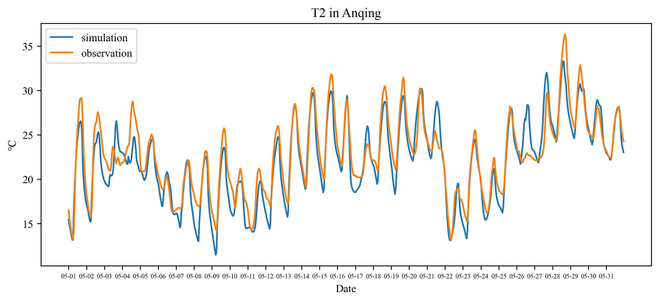

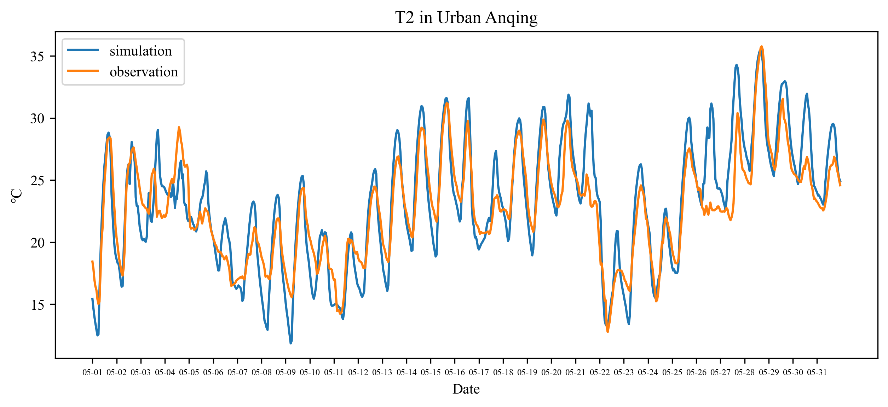

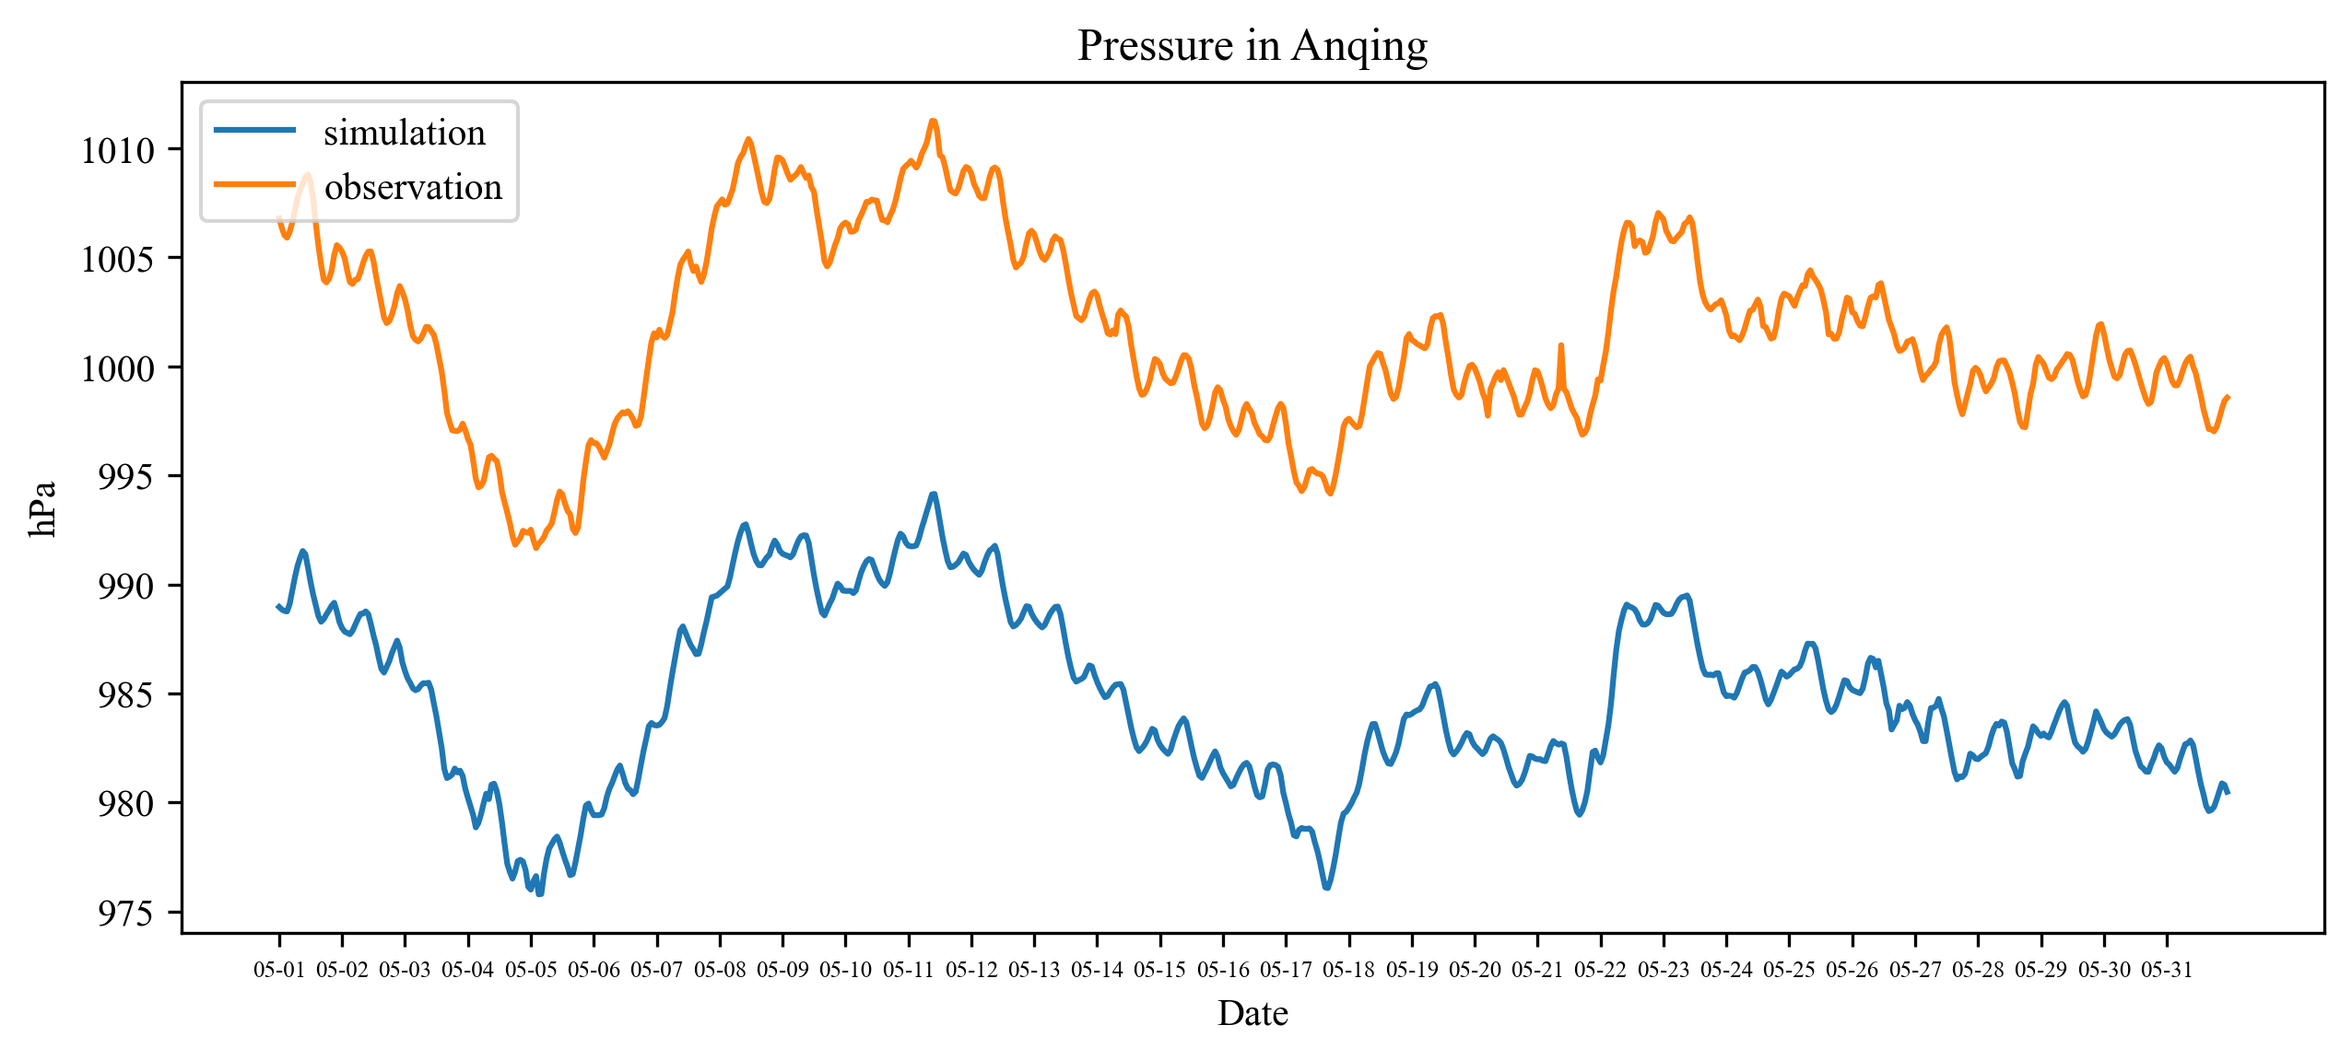

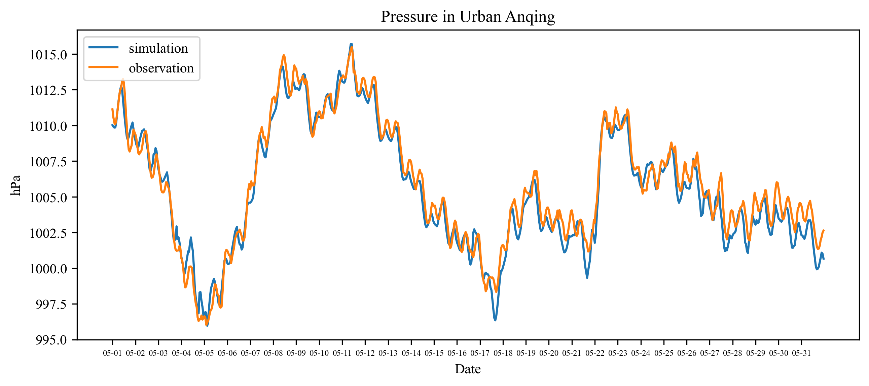

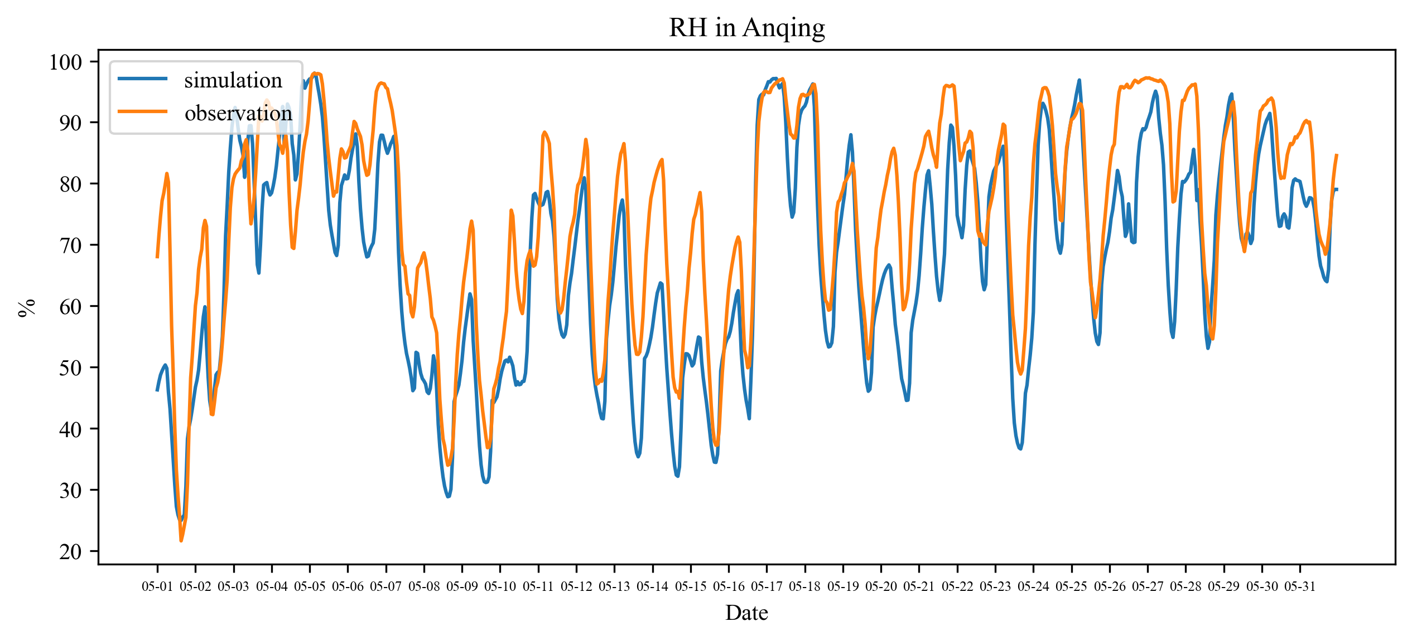

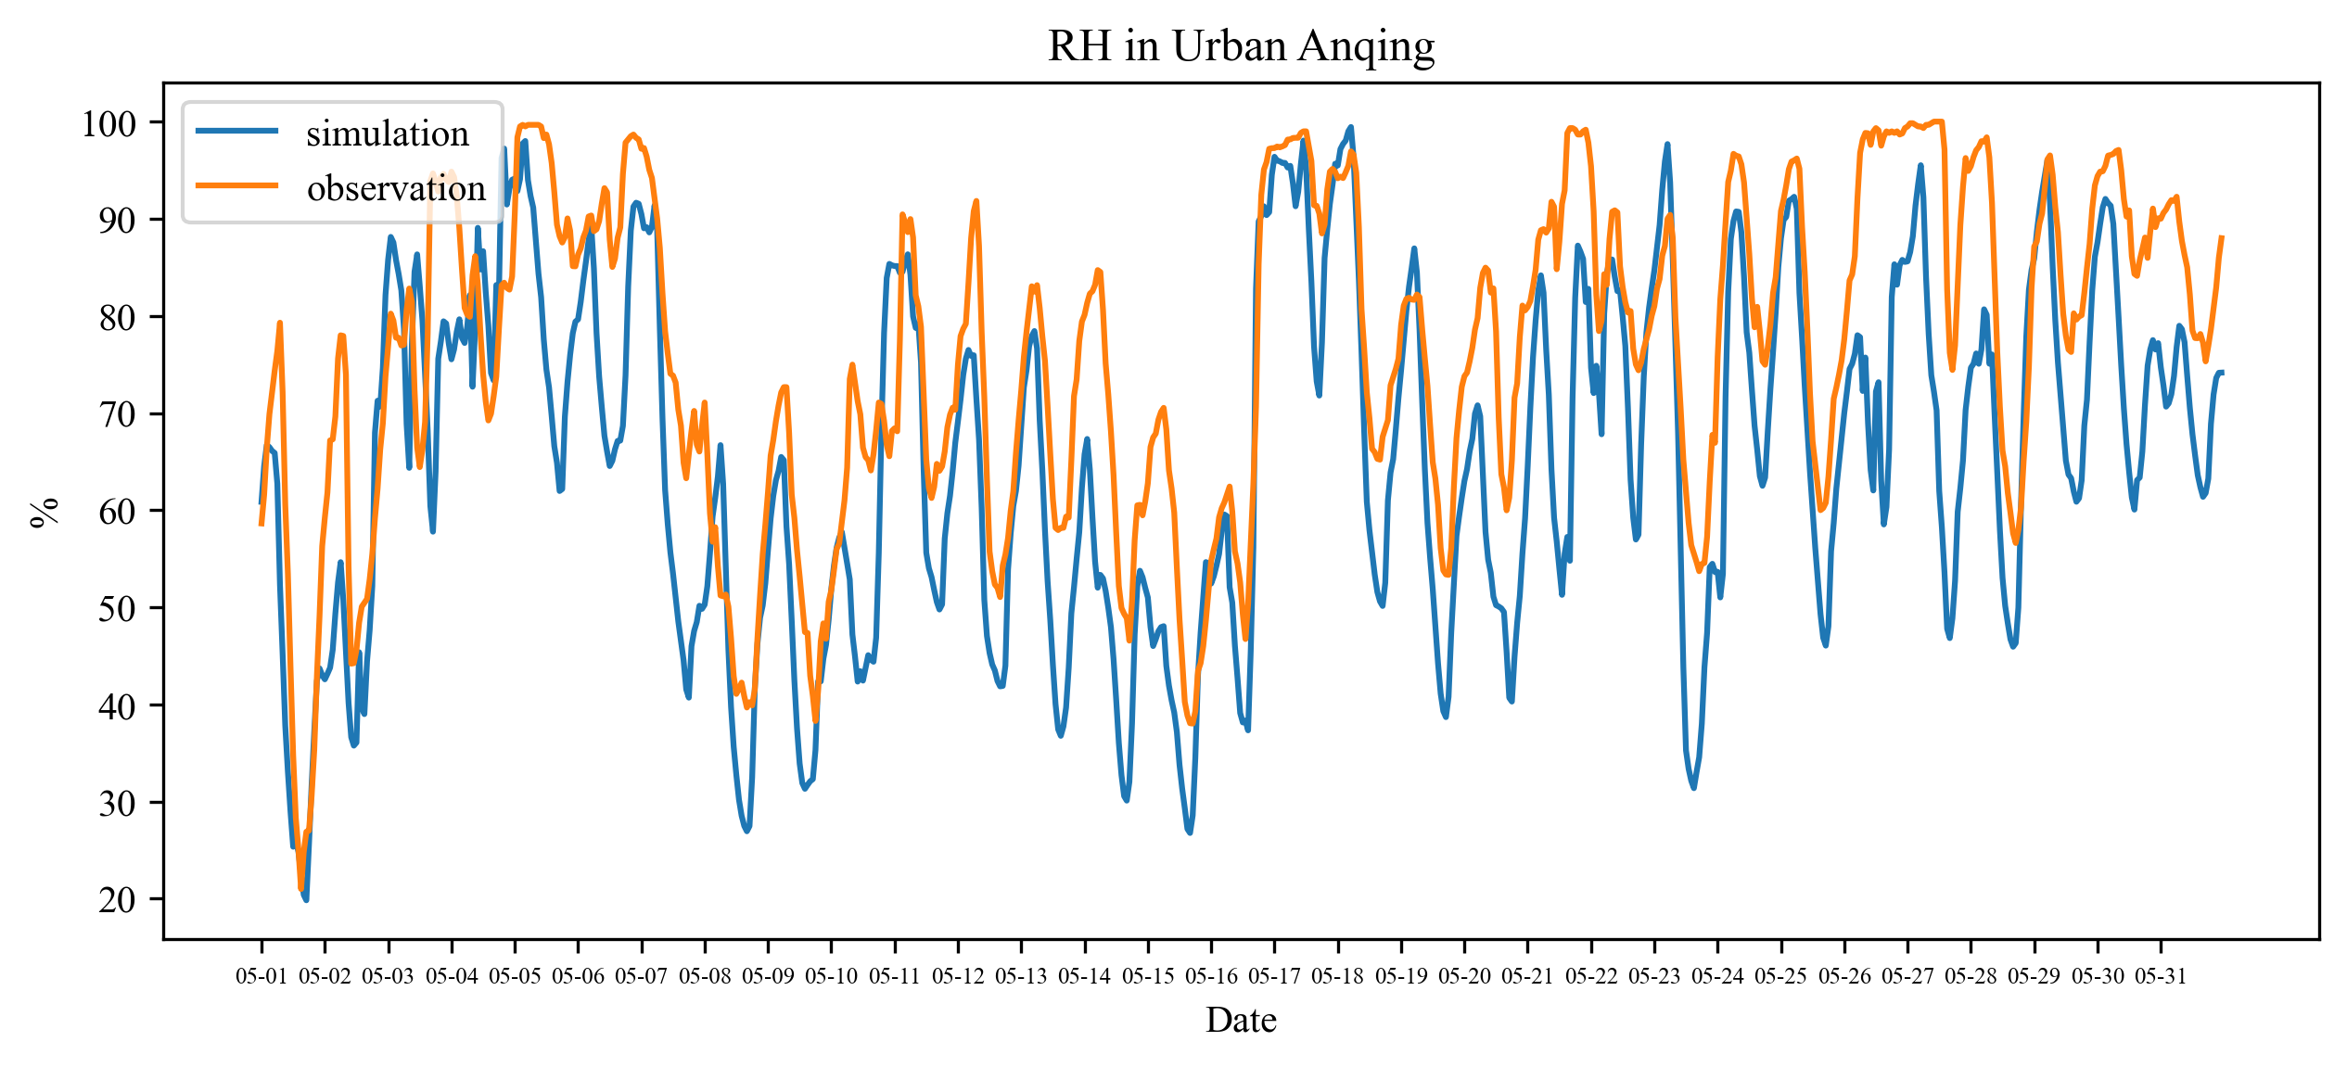

说明：本次风速未调整为原本的一半

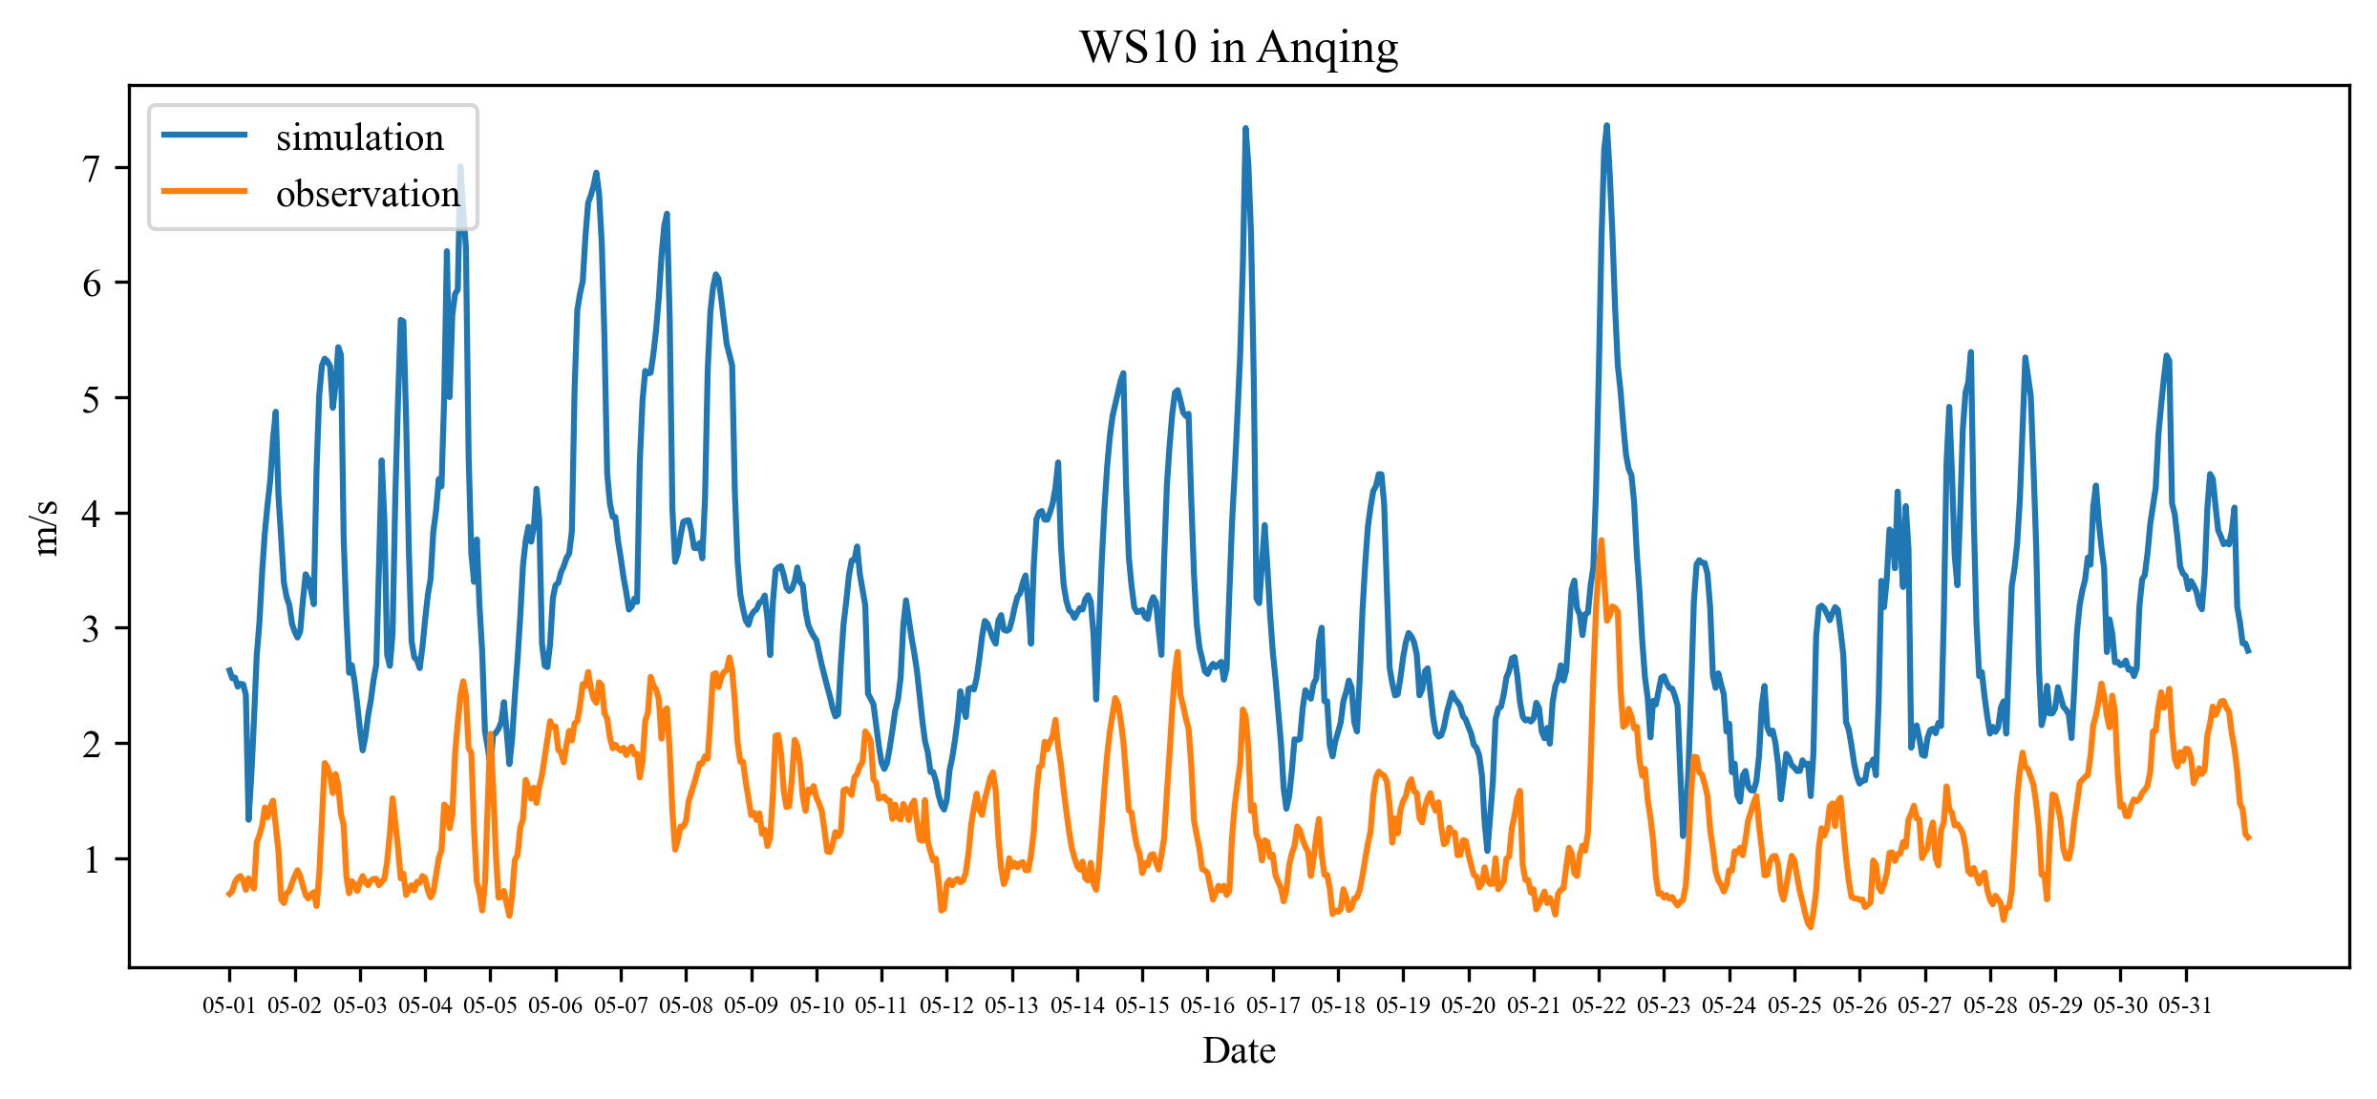

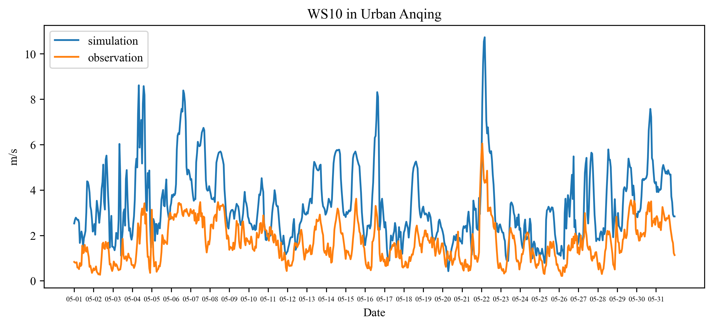

**二、化学场**

|  |  |  |  |  |  |  |
| --- | --- | --- | --- | --- | --- | --- |
| **要素**(ug/m3) | $$\overline{O}$$ | $$\overline{S}$$ | ***MB*** | ***R*** | ***RMSE*** | ***IOA*** |
| 全市O3 | 83.20 | 118.28 | 35.08 | 0.50 | 52.34 | 0.60 |
| 城区O3 | 87.69 | 100.47 | 12.79 | 0.45 | 49.91 | 0.65 |
| 全市NO | 2.55 | 1.15 | -1.40 | 0.07 | 3.22 | 0.32 |
| 城区NO | 2.71 | 2.84 | 0.13 | 0.04 | 6.46 | 0.21 |
| 全市NO2 | 15.70 | 11.61 | -4.09 | 0.23 | 9.98 | 0.52 |
| 城区NO2 | 17.40 | 21.83 | 4.43 | 0.22 | 17.10 | 0.47 |
| 全市PM2.5 | 25.55 | 25.00 | -0.55 | 0.55 | 14.48 | 0.72 |
| 城区PM2.5 | 27.90 | 27.16 | -0.74 | 0.34 | 18.56 | 0.58 |
| 全市PM10 | 46.24 | 30.27 | -15.97 | 0.39 | 29.47 | 0.59 |
| 城区PM10 | 49.39 | 34.64 | -14.75 | 0.24 | 39.13 | 0.48 |

